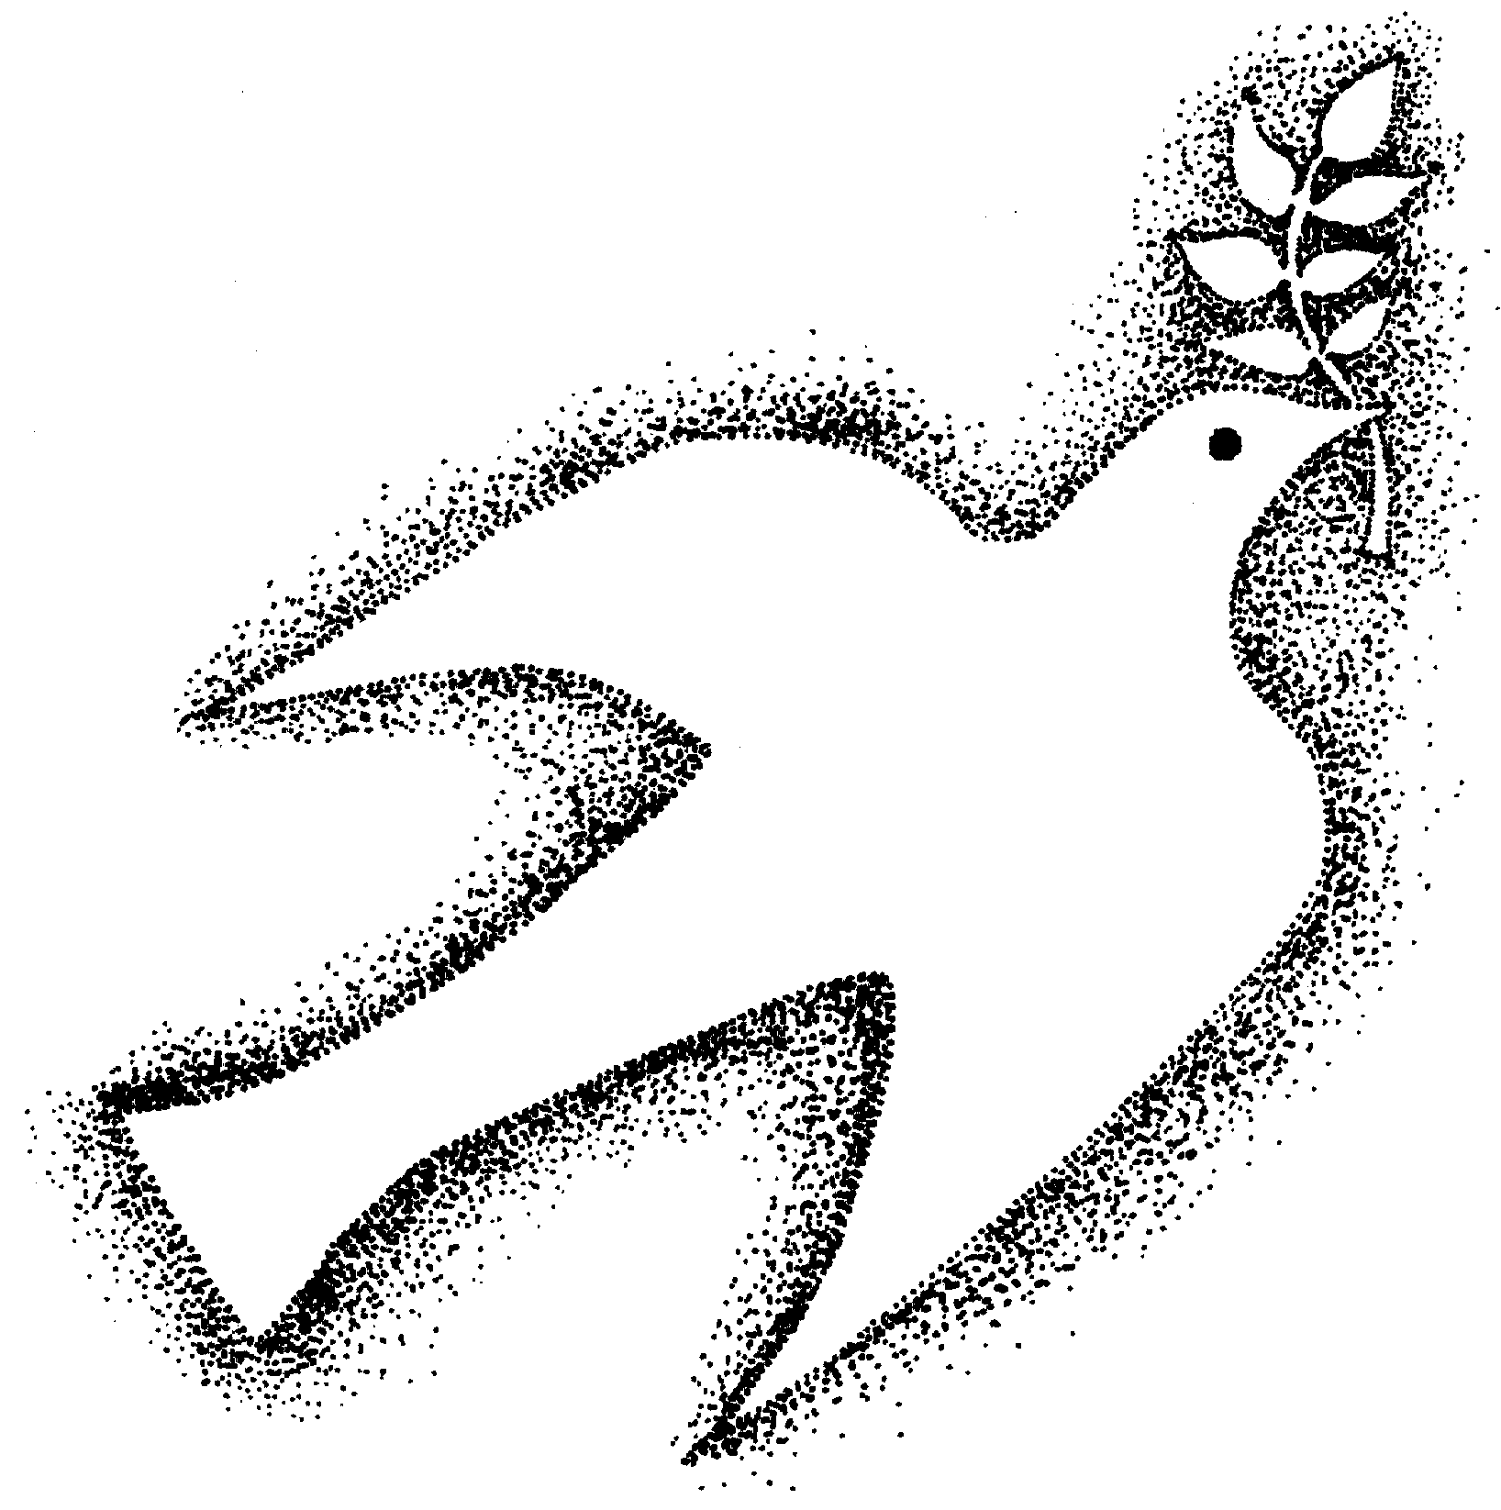
Holy Spirit Retreat Center
4316 Lanai Road Encino CA 91436
Phone: 818-784-4515 Fax: 818-784-0409
www.hsrcenter.com hsrcenter@earthlink.net


ONGOING CENTERING PRAYER GROUPS
Mary Shear & Linda Snow, CSJ

Centering Prayer is a silent meditation practice intended to deepen one’s relationship with God. The group sessions include time for communal Centering Prayer, a contemplative walk, input from a Spiritual Journey video or book by Thomas Keating and group sharing. If new to the practice we highly recommend the Centering Prayer Introductory Workshop. For more information, please call Sister Linda Snow at 818-784-4515 x3317.

TUESDAYS – 7-9pm
January 6, 20; February 3, 17; March 3, 17, 31; April 14,28; May 12,26; June 9,23; July14, 28

THURSDAYS – 9:30-11:30am
January 15, 29; February 12, 26; March 12,26; April 9, 23; May 7,21; June 4,18; July9, 23

Suggested donation $5

xxxxxxxxxxxxxxxxxxxxxxxxxxxxxxxxxxxxxxxxxxxTEAR & SENDxxxxxxxxxxxxxxxxxxxxxxxxxxxxxxxxxxxx

Centering Prayer Groups

Name____________________________________Phone (_______)______________
Address_______________________________________________________________
City_______________________________________State_____Zip________________
Email_________________________________________________________________

